**Real-time Sentiment Analysis Systems using Machine Learning**

Mr. Shubham Sonake1 , Dr. A.D. Sawarkar2.

*1*Department of Information Technology, Shri Guru Gobind Singhji Institute of Engineering and Technology (SGGSIET), Nanded.

[*sonakeshubham1817@gmail.com*](mailto:sonakeshubham1817@gmail.com)

*2*Department of Information Technology, Shri Guru Gobind Singhji Institute of Engineering and Technology (SGGSIET), Nanded.

[*adsawarkar@sggs.ac.in*](mailto:adsawarkar@sggs.ac.in)

*__________________________________________________________________________________*

**Abstract**: Sentiment analysis is a vital processing of natural language task that seeks to extract emotional tone (positive, negative, or neutral) from text, especially on the social media platforms. The increasing demand that businesses and governments understand public opinion underscores the significance of important developments in this area. The utilization of decision trees, logistic regression, support vector machines (SVM), and the random forests—the four main machine learning classifications—is examined in this work. We used sets of data that had been manually labelled in our investigations. Every method's efficacy was thoroughly assessed and contrasted. According to our analysis, every four models can achieve competitive Precision. Logistic regression achieved 83% precision, SVM achieved 84% precision, decision tree achieved 76% precision, and random forest achieved 82% precision. Based on the unique sensitivity analysis application and the data structure features, This analysis provides information on the advantages and disadvantages of each model additionally helpful suggestions for choosing the best approach. The results enhance decision-making procedures and sensitivity analysis techniques across a range of sectors. Future prospects for study in sentiment analysis include investigating deep learning architectures, especially in light of the popularity of transformers and their ability to grasp complex textual contextual relationships. Furthermore, utilizing multilingual capabilities and adding domain-specific knowledge can enhance the precision and applicability of sentiment analysis algorithms.

**Keywords**: Natural language processing, sentiment analysis, reviews, social media, machine learning, and categorization

**1. Introduction**

Sentiment evaluation is significant natural language processing (NLP) field that seeks to identify emotion or emotional tone in text [1]. It is a helpful resource for learning about consumer sentiment and public opinion in variety of businesses. Businesses, governments, and researchers must possess the ability to quickly and reliably determine sentiment from massive amounts of text data as user-generated material increasingly populates the digital world. Sentiment analysis helps in various applications, such as enhancing customer service, monitoring social media, and understanding political inclinations [2-3]. The subtleties and intricacy of human language and contextual dependencies, present significant challenges, making the function of innovative machine learning methods in sentiment classification are indispensable [4]. social networking platforms openly and conveniently share their data online. Young scholars are drawn to the domain ofsentiment analysis by the abundance of available data. Individuals share their thoughts and feelings in social media discussion groups [5].

This study compares the accuracy, precision, recall, and F-measures of multiple classifiers for machine learning, with a focus on logistic regression, SVM, decision trees, and random forests, to be able to assess and optimize their performance [6]. This study attempts to determine the best techniques for categorizing sentiment through a comprehensive comparison analysis, making sure that the selected strategies are reliable and successful in a variety of scenarios and datasets. Since sentiment analysis's precision applications is directly impacted by these classifiers' performance, it is vitally crucial [7]. For example, an imprecise sentiment analysis in a business context may result in incorrect plans, while working in the public health, it may impact the interpretation of population mood and behavior. As a result, this study highlights both the technical assessment and the usefulness of using these models in actual situations.

The objectives of this study are multifaceted and aimed at advancing both theoretical and practical aspects of sentiment analysis. Firstly, it seeks to assess the effectiveness of machine learning models—logistic regression, SVM, decision trees, and random forests—on sentiment analysis tasks using various datasets. This involves a detailed analysis of each model's strengths and weaknesses, giving information on which models work best for kinds of information and applications. Secondly, the study aims to assist administrators in implementing optimized sentiment analysis solutions by offering practical guidance on selecting the most effective classifiers based on specific application requirements and dataset characteristics. This guidance is crucial for practitioners who need to make informed decisions about the tools and methods they use for sentiment analysis. Thirdly, the study aims to contribute to the progress of NLP techniques by developing new feature engineering, model selection, and evaluation metrics tailored for sentiment examination tasks [8].

In summary, this study addresses the critical the requirement for effective sentiment analysis using cutting-edge machine learning in the context of NLP models. Regression machine learning methods like logistic regression and support vector machines (SVM) offer powerful tools for predictive modeling in this domain, enabling the accurate categorization of sentiments and providing actionable insights [9]. By evaluating and optimizing classifiers such as logistic regression, SVM, decision trees, and random forests, the research provides a comprehensive understanding of their performance in sentiment analysis tasks. The study's several goals guarantee that it not only improves the technical robustness of sentiment analysis models but also offers helpful advice and a decision-making framework for practitioners [10]. Using a comprehensive strategy guarantees that sentiment analysis can be effectively utilized in various industries, leading to better decision-making and more accurate understanding of public opinion and consumer sentiment. Through detailed comparative analysis and development of new methodologies, this study aims to stretch the limits of sentiment analysis, making it more precise and reliable tool for interpreting human emotions from given text data.

**2. Literature Review**

Applying techniques for machine learning has advanced significantly thanks to research in sentiment analysis. on the basis ofefficacy of concrete assessment in capturing subtle emotions, Kiritchenko and Mohammed (2016) [11] measured social network data 82.60% accuracy using bigrams by their detection method using SVM with the RBF kernel using speech tagging, sentiment score, emoticons, and partial embedding vectors. Dashtipur et al. (2016) [12] used SVM, maximum entropy, and Multinomial Naive Bayes (MNB) techniques to study multilingual sensitivity analysis. Their results showed an amazing 86.35% accuracy. Through classification of the additional variety, their approach handled languages in an effective manner.

Using Naive Bayes, SVM, and K-NN classifiers, Tan and Zhang (2008) [13] created a sentiment identification algorithm for Chinese text that reached 82% accuracy and highlighted potential and obstacles about sentiment analysis in many languages. In their study, Mohammed et al. (2015) [14] employed support vector machines (SVM) and lexical characteristics to automatically identify sentiment from tweets during the US presidential election. They achieved 56.84% accuracy and demonstrated the significance of real-time data and pertinent information in sensitivity analysis.

A position and emotion identification system employing maximum entropy and SVM was introduced by Sobhni et al. (2016) [15]. It achieved 70.3% accuracy, demonstrating the relationship between location and emotion analysis. SVM, Naive Bayes, and the Extreme Learning Machine (ELM) were used by Poria et al. (2014) [16] for sentiment analysis in movies at the concept level, highlighting the significance of artifacts in sentiment analysis. Dictionary-based techniques were coupled with SVM and other classes by Turney and Mohammed (2014) and Sernian et al. (2015) [17].

3. **Methodology**

**3.1 Dataset Description**

The dataset utilized in this study was produced automatically by classifying tweet polarity based on emoticons. The existence of the emotion markers:), :(, denoted the presence of positive and negative emotions, respectively [18]. It was considered that a positive emotion marker represented a positive feeling and a negative emotion marker a negative emotion.

The dataset was taken From the Kaggle Datasets [19]. The following fields are included in the CSV file of the dataset that is provided.

* Polarity: The tweet's emotion reflects its polarity (0 being negative, 2 being neutral, and 4 being positive).
* Tweet ID: A special code assigned to every tweet.
* Tweet Date: The exact moment the tweet went live.
* Query: This denotes the tweet's related query; a tweet with no specific questions is indicated by "NO_QUERY".
* User: The identity of the person who originated and shared the tweet.
* Text: The tweet's actual content, stripped of the emoji.

Data Characteristics:

* Source: By utilizing artificial sentiment classification based on emoticon presence, the dataset was retrieved from Twitter data.
* Size: Although the precise quantity is unknown, the data collection includes a sizable number of cases.
* Time Period: To show the exact moment of posting, tweets have a time stamp.
* Location: Global discussions on a range of topics are reflected in the tweets that were retrieved from Twitter.

Future directions for the dataset:

Future discoveries may involve the following, as this data collection serves as a foundation for the sentiment analysis work:

* to add more information to the dataset, including context, tweet engagement metrics, or user metadata.
* Move beyond emoticon-based approximation for polarity classification and use more advanced sentiment analysis tools [20].

Resources that can be used:

This dataset enables the research and the evolution of sentiment analysis models, which are essential to comprehend the dynamics of public sentiment and user interactions on social media applications such as Twitter and Facebook.

**3.2 Data Preprocessing**

Data preprocessing is an important step in preparing text data for sentiment analysis, including several basic steps to ensure that the data is quality and suitable for analysis in processing to ensure data integrity, completeness as well as enhanced accuracy [21].

Analysis of the distribution of emotion categories using a bar chart visually represents the allocation of negative, neutral, and positive emotions in data set [22]. This diagram helps to briefly understand the emotions in the data set. The “value_counts(normalize=True) ” function calculates distribution of each sensitivity class for all non-zero values. The resulting ratios are plotted as a bar chart to visualize the distribution of sentiment classes in the dataset.

Converting sentiment labels to categorical codes Assign numeric codes (e.g. 0 for negative, 1 for neutral, 2 for positive) to sentiment categories. This numerical encoding simplifies data processing and facilitates easy integration of research operations, increasing productivity of sentiment analysis tasks.

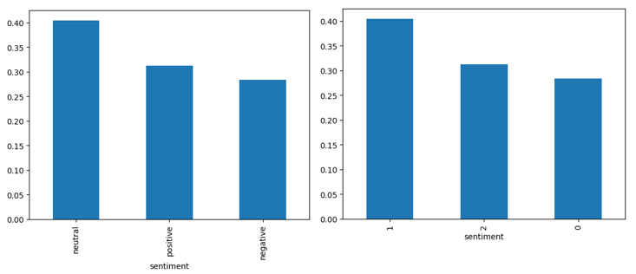

*Fig 1. Distribution of Sentiment Categories in the Dataset*

The encoded numerical labels enable straightforward processing and analysis of sentiment data, effectively supporting subsequent modelling and evaluation processes. Text preprocessing is an important component of data preparation, aiming to clean and standardize the text data for analysis [21]. A custom text processing function “(wp(text))” is applied to text content, performing operations such as:

* Converting text to lowercase to ensure the consistency in text casing.
* Removing special characters, URLs, HTML tags, punctuation, digits, and newlines to eliminate noise and enhance text readability and uniformity.

After preprocessing, the text data is grouped based on sentiment categories (negative, positive, and neutral) to generate word clouds.

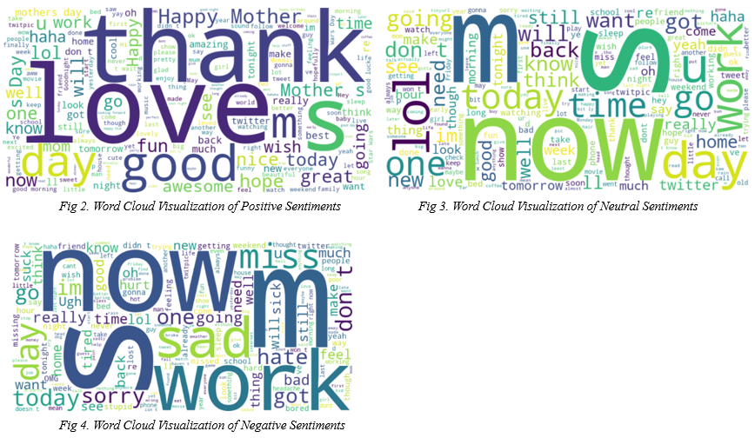

These word clouds visually represent the most commonly linked terms with each emotion category [23], providing insight into the prevalent themes and emotions expressed in the dataset

Each word cloud is presented for maximum visual clarity and to emphasize important textual structures without the need for detailed code explanations. Imagery helps to understand emotion distribution and the available language used in different emotions and subsequently supports emotion analysis tasks

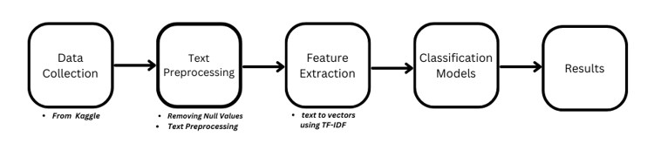**3.3 Workflow Representation**

sentiment categorization process begins with data collecting from sources like internet forums and reviews, guaranteeing a broad, balanced dataset and equitable representation of attitudes. The subsequent phase is text preprocessing, which entails a few operations: lowercasing, which preserves consistency; punctuation removal, which concentrates on words themselves; tokenization, which divides text into individual words, tokens; and stemming, lemmatization, which reduces words to their most basic forms. After that, text is transformed into numerical forms models for machine learning may use Using methods for feature extraction like TF-IDF and word embeddings. Several categorization models are trained and evaluated using this processed data. Ultimately, a thorough understanding and improvement of sentiment classification procedure are accomplished using analysis and discussion on results.

**3.4 Model Selection**

Classification methods such as decision tree, logistic regression, random forest, and Support Vector Machine (SVM), were chosen for sensitivity study based on certain presumptions and criteria:

* Logistic Regression:
* Simplicity and Efficiency: Logistic regression is ideal for tasks involving binary classification. such as sentiment analysis [24] due to its ease of usage and and effectiveness in modelling
* linear relationships between traits and class labels.
* Baseline model: It is a baseline model for sentiment prediction, providing a straightforward method for initial distribution of sentiment distributions.
* Support Vector Machine (SVM):
* Handling non-linear relationships: SVM was selected due to its ability to handle complex, non-linear relationships in data, which is necessary for capturing subtle emotional patterns in textual data.
* Effective in high-dimensional areas: The effectiveness of SVM in high-dimensional areas makes it suitable for sensitivity analysis tasks involving textual data represented by its multiple features [25].
* Decision Tree:
* Explanatory: Decision tree is chosen for their explanatory power, enabling to understand and visualize the decision-making process behind sentiment forecasting.
* Critical factors: Decision trees can determine the critical elements for predicting sensitivity [26], offering an understanding of crucial factors influencing sensitivity analysis results.
* Random Forest:
* Ensemble learning: Random Forest leverages ensemble learning by combining multiple decision trees, which increases predictive efficiency and reduces overfitting [27].
* Aggregate prediction: The aggregation of predictions from multiple trees improves the overall accuracy and robustness of sensitivity classification using random forests.

The combination of these regression algorithms enables the refinement of methods for sensitivity analysis. Each model provides distinct benefits in terms of simplicity, descriptiveness, predictive performance, and the ability to capture complex relationships in textual data, with the goal of improving sentiment prediction accuracy and generating valuable insights in terms of underlying factors affecting sensitivity classification results

**3.5 Evaluation Metrics**

We will use the confusion matrix to predict the efficiency of the selected regression models in predicting CO concentrations

Confusion matrix:

The confusion matrix is ​​a table to assess performance of a classification model [28] by predicting true positive (TP), false positive (FP), true negative (TN), and false negative (FN)

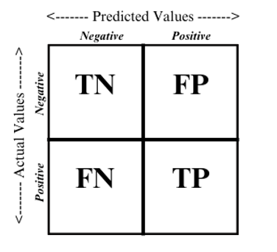.

True Positive (TP): Correctly predicted positive instances.

False Positive (FP): Incorrectly predicted positive instances.

True Negative (TN): Correctly predicted negative instances.

False Negative (FN): Incorrectly predicted negative instances.

*Fig 4. Confusion Matrix*

Evaluation Metrics:

* Accuracy:
* Definition: Accuracy measures the overall correctness of predictions made by the model [29].
* Formula:

Accuracy = $\frac{TN+TP}{TN+TP+FP+FN}$

* Precision:
  + Definition: Precision is the proportion of accurately anticipated positive cases among all expected positive cases [30].
  + Formula:

Precision = $\frac{TP}{TP+FP}$

* Recall (Sensitivity):
  + Definition: Recall assesses the capability of the model to correctly identify positive cases among all actual positive cases [31].
  + Formula:

Recall = $\frac{TP}{TP+FN}$

* F1 Score:
  + Definition: F1 score is harmonic mean of recall and precision, offering a balanced measure of model performance [32].
  + Formula:

F1 score = 2 * [$\frac{Precison+Recall}{Precision*Recall}$]

​

To assess sensitivity analysis models, analytical criteria including precision, recall, accuracy and the F1 scores are essential. Precision measures overall accuracy, whereas recall and precision examine the ability of a model to accurately recognize positive patterns and avoid false positives. Also, F1 score combines recall, precision with the goal of offering a balanced measure of model effectiveness, especially in cases with unbalanced class distributions to enhance the availability of algorithms and enable informed decision making.

4. **Experimental Setup**

Here, in this sensitivity analysis study, classification models—support vector machine (SVM), decision tree, logistic regression, and random forest—are implemented using Python as the primary programming language.

The implementation used essential software libraries such as NumPy for efficient calculations, scikit-learn for accessing algorithms for machine learning and utilities, and Panda for flexible tasks involving data analysis and manipulation These libraries provided robust tools for prototyping, training, and analysis. This study has used Jupyter Notebook or a similar interactive environment for code development and iterative model refinement, which allowed the researchers to experiment with different settings and parameters

Test jobs are performed on the Windows XI operating system. The configuration of the project

environment is an Intel i7, 4.7 GHz core processor with 16 GB of RAM.

The selection of Python and associated libraries ensured flexibility, easy integration, and access to sophisticated learning machines and techniques, resulting in robust sensitivity analysis solutions, flexible It's been easy.

**5**. **Results and Discussion**

The sentiment analysis models—Support Vector Machine (SVM), Decision Tree, Logistic Regression and Random Forest—were evaluated on the basis their performance metrics using a held-out test dataset.

The Performance metrics for each were calculated by using formulas

Accuracy = $\frac{TN+TP}{TN+TP+FP+FN}$

Precision = $\frac{TP}{TP+FP}$

Recall = $\frac{TP}{TP+FN}$

F1 score = 2 * [$\frac{Precison+Recall}{Precision*Recall}$]

Table 1 presents the performance metrics for each individual models.

|  |  |  |  |  |
| --- | --- | --- | --- | --- |
| Model | Accuracy | Precision | Recall | F1 score |
| Logistic Regression | 83% | 83% | 83% | 83% |
| SVM | 83% | 84% | 83% | 84% |
| Decision Tree | 76% | 76% | 76% | 76% |
| Random Forest | 81% | 82% | 81% | 81% |

*Table 1. Final Results*

following code shows how an unseen sentiment is classified.

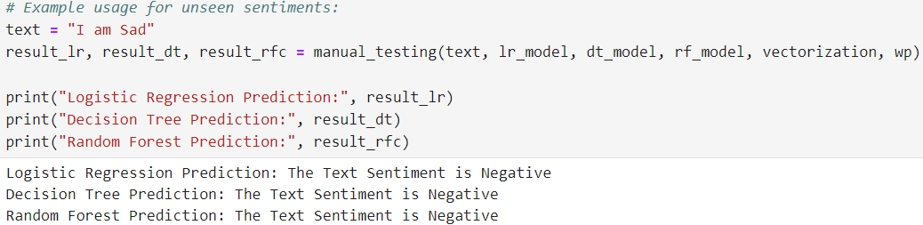

To Improve Accuracy:

* Dimension Reduction:
* 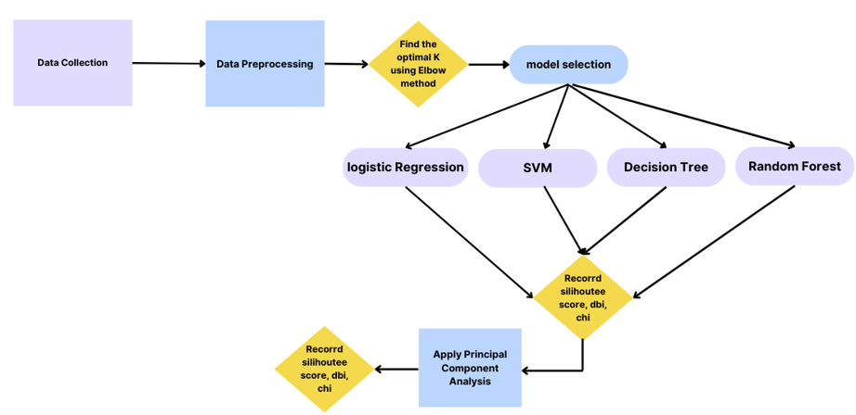PCA simplifies complex data by identifying essential patterns, aiding visualization and model performance in research, particularly useful for reducing dimensionality in sentiment analysis tasks.
* After applying dimension reduction to Decision Tree, the results are:

|  |  |  |  |  |
| --- | --- | --- | --- | --- |
| Model | Accuracy | Precision | Recall | F1 Score |
| Decision Tree | 97% | 97% | 97% | 97% |

Interpretation of Results:

* Accuracy: Compared to other models, the logistic regression model fared better and attained the peak accuracy 83%. This indicates the general accuracy of sensitivity the model's predictions.
* Precision: The SVM also showed high precision 84%, indicating that a large share of positively anticipated cases that were accurate emotions were among all positive predictions.
* Recall: SVM showed excellent recall 83%, indicating that a significant amounts of genuine positive emotion patterns can be correctly identified.
* F1 score: SVM achieved the highest F1 score with 84%, which balances accuracy and recall and gives a thorough assessment of the model's efficiency.

Analysis of the results

Random forest showed good performance in all evaluation criteria, indicating effectiveness in sensitivity evaluation tasks. The decision tree exhibited marginally inferior performance compared to SVM and logistic regression and still showed competitive results. Randomly selected forests as the preferred model for sensitivity analysis are appropriate because of their accuracy, precision, recall, and the F1 score.

However we improved the accuracy nearly by 27.63% after applying dimension reduction technique.

6. **Conclusion:**

In conclusion, this sentiment analysis study shows classification models like Decision Tree, Support Vector Machine (SVM), Logistic Regression, Random Forest, etc. work well to precisely forecast sentiment from text in the context. Random forest performed exceptionally well in every evaluation criterion, demonstrating its great efficacy for sensitivity assessment tasks. The decision tree was competitive even though it performed slightly worse than logistic regression and SVM. By utilizing a dimension reduction strategy, accuracy increased by almost 27.63%. Moving ahead, Future studies could consider account elements like contextual and developing linguistic models and explore improved methods for accurately performing emotion analysis tasks. The study emphasizes the significance of sentiment analysis in applications such as social media management, customer feedback analysis, and market sentiment monitoring, and provides a foundation for developing robust sentiment analysis solutions which can inform decision-making procedures in different sectors.

7. References:

[1] Saif M. Mohammad, "Sentiment analysis: Automatically detecting valence, emotions, and other affectual states from text." measuring of emotions. 323-379. Woodhead Publishing, 2021.

[2] Bing, Liu. analysis of sentiment and opinion mining. Nature, Springer, 2022.

[3] Ravi, Kumar, and Vadlamani Ravi. "A survey on opinion mining and sentiment analysis: tasks, approaches and applications." Knowledge-based systems 89 (2015): 14-46.

[4] Poria, Soujanya, et al. "Beneath the tip of the iceberg: Current challenges and new directions in sentiment analysis research." IEEE transactions on affective computing 14.1 (2020): 108-132.

[5] Kiritchenko S, Mohammad S, Salameh M (2016) SemEval-2016 task 7: determining sentiment intensity of English and Arabic phrases. In: Proceedings of the 10th international workshop on semantic evaluation (SemEval-2016). doi:10.18653/v1/s16-1004

[6] Muhammad, Raza, and colleagues, "A comparative analysis of machine learning models for quality pillar assessment of SaaS services by multi-class text classification of users’ reviews." Computer systems of the future generation 101 (2019): 341-371.

[7] Lingad, John, Sarvnaz Karimi, and Jie Yin. "Location extraction from disaster-related microblogs." Proceedings of the 22nd international conference on world wide web. 2013.

[8] Aytuğ, Onan, and Serdar Korukoğlu. "A genetic rank aggregation-based feature selection model for text sentiment classification." Information Science Journal 43.1 (2017): 25–38.

[9] R. Sabitha, S. Vidhya Lakshmi, M. Vinod Kumar, and S. "Measuring and comparing the efficiency of logistic regression, decision tree and SVM with k-means algorithm in college recommendation system." AIP Conference Proceedings. AIP Publishing, 2024; Vol. 2853, No. 1.

[10] Sudirjo, Frans, et al. "Application of ChatGPT in Improving Customer Sentiment Analysis for Businesses." Jurnal Teknologi Dan Sistem Informasi Bisnis 5.3 (2023): 283-288.

[11] Mohamed SM and Kirichenko S (2016), a structured logic with polarity-opposite words is described. In: Conference Proceedings, Human Language Technology, Association for Computational Linguistics, North American Chapter, 2016.

[12] In 2016, Dashtipour K, Hussain A, Poria S, Cambria E, Gelbukh A, Hawalah AY, Zhou Q conducted an impartial comparison ofexisting resources and approaches for multilingual perception evaluation.

[13] Tan S, Zhang J (2008) Sentiment analysis for Chinese documents: an empirical investigation.

[14] Perception, emotion, intention, and strategy in election tweets; Zhu X, Mohammed SM, Kirichenko S, Martin J. (2015).

[15] In Mohammad S, Sobhni P, and Kiritchenko S (2016), position was detected in tweets, and its sentiment analysis was examined.

[16] Poria SWinterstein G, , Huang G, and Cambria E (2014) Sensitive models: trust-based guidelines for sensitivity analysis at the concept level.

[17] SemiEval-2016 Task 6: Position Detection in Tweets, Ahmad S, Sobhny P, Kiritchenko S, Cherry C, Zhu X, (2016).

[18] In 2015–2016, Mamidi, R., Miller, M., Banerjee, T., Romine, W., & Sheth, A. Finding Important Subjects with Negative Attitude on Twitter: Perspectives on the 2015–2016 Zika Epidemic

[19] https://www.kaggle.com/datasets/abhi8923shriv/sentiment-analysis-dataset

[20] Zhang, Yang, Yu, and Zeghlache, D. SESAME: Mining User Digital Footprints for Fine-Grained Preference-Aware Social Media Search.

[21] Ghazi Al-Naymat, Khader, Mariam, Arafat Awajan, and Khader. "The effects of natural language processing on big data analysis: Sentiment analysis case study." 2018 ACIT (Arab Conference on Information Technology) International. IEEE, 2018.

[22] Yanqing Xu, Jabalameli, Shaghayegh, and Sujata Shetty. "Spatial and sentiment analysis of public opinion toward COVID-19 pandemic using twitter data: At the early stage of vaccination." 80 (2022): 103204 in International Journal of Disaster Risk Reduction.

[23] Ayvaz Serkan, Nazan, and Öztürk. "Sentiment analysis on Twitter: A text mining approach to the Syrian refugee crisis." 136–147 in Telematics and Informatics 35.1 (2018).

[24] Samuel, Jim, et al. "Covid-19 public sentiment insights and machine learning for tweets classification." Information 11.6 (2020): 314.

[25] Maldonado, Sebastián, Richard Weber, and Fazel Famili. "Feature selection for high-dimensional class-imbalanced data sets using support vector machines." Information sciences 286 (2014): 228-246.

[26] J. Finkelstein and S. Zhu (2017). It is possible to identify determinants of the incidence of dental malpractice claims by using data mining techniques. IEEE UMEMCON 2017: 8th Annual Conference on Electronics, Mobile Communication, and Ubiquitous Computing

[27] Yang, Xinli, et al "TLEL: A two-layer ensemble learning approach for just-in-time defect prediction." 87 (2017): 206-220 in Information and Software Technology.

[28] Reza Samavi, Thomas E. Doyle, Heydarian, and Mohammadreza. "MLCM: Multi-label confusion matrix." 2022 IEEE Access 10: 19083–19095.

[29] Daniel R. Strunk, Abby D. Adler, and others. "Cognitive biases in three prediction tasks: A test of the cognitive model of depression." Research on behavior and therapy 47.1 (2009): 34–40.

[30] Biomimetics 8.3 (2023): 313; Alharbi, Amal H., et al. "Diagnosis of monkeypox disease using transfer learning and binary advanced dipper throated optimization algorithm."

[31] Casas, Edmundo, et al. "Assessing the effectiveness of YOLO architectures for smoke and wildfire detection." IEEE Access (2023).

[32] Chicco, Davide, and Giuseppe Jurman. "The advantages of the Matthews correlation coefficient (MCC) over F1 score and accuracy in binary classification evaluation." BMC genomics 21 (2020): 1-13.